Assignment # 6 – DOM Manipulation using JS

Tasks to complete:
Refer the below screenshot to implement the DOM Manipulation using JS.
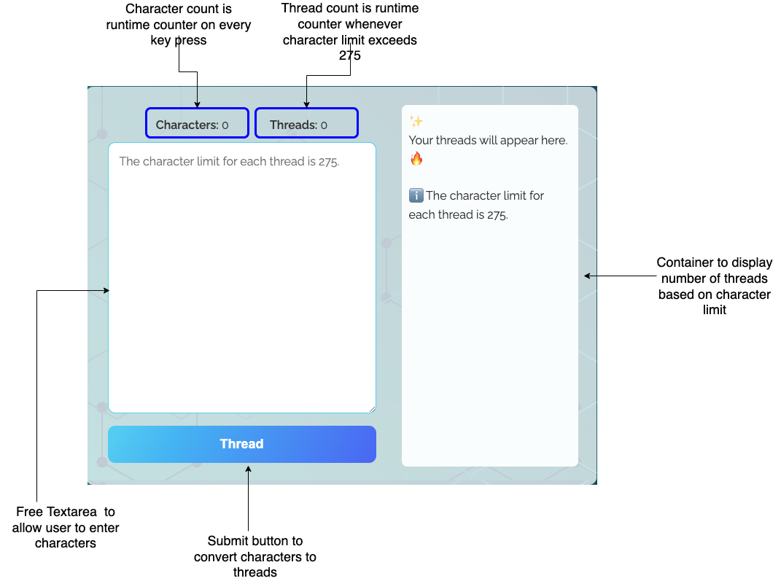
Below mentioned screen describes the thread formation based on number of characters
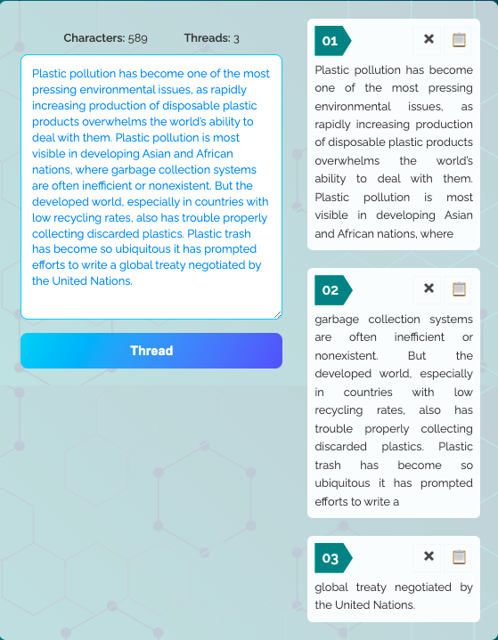

Note: Follow the step in ReadMe file to run test cases.

Submission Steps
- Use Same previously cloned repo (No Need to create new repo, if Importing of repo already done.)

- Open you Repo in VSCODE and in terminal type cd "Repo name”.

- git checkout -b "BranchName"
Note: Branch Name should be the Assignment Number for example : Assignment 6, command would be
git checkout -b Assignment-6

- Start making changes in assignment6.html and assignment6.css.
- Proceed with Staging using command git add . or use Vs code extension
- Git commit or use Vs code extension
- Git Push or use Vs code extension
- Create the Merge Request as mentioned in below screenshots.
  - Select the branch that checkout in step 4
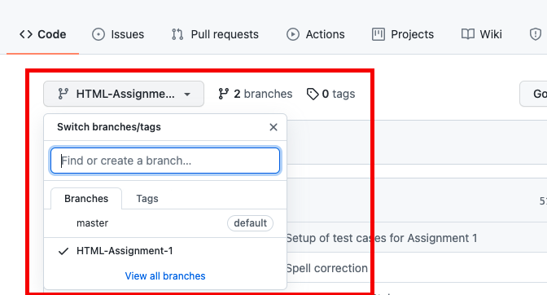

  - Click on “Pull request”
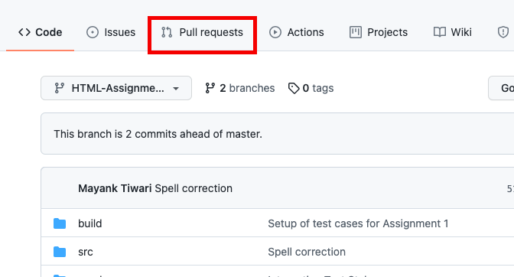
  - Click on “New Pull Request”
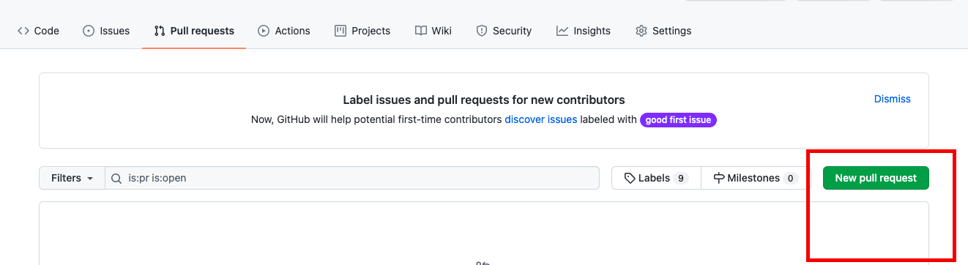

  - Select the branch that checkout in step 4
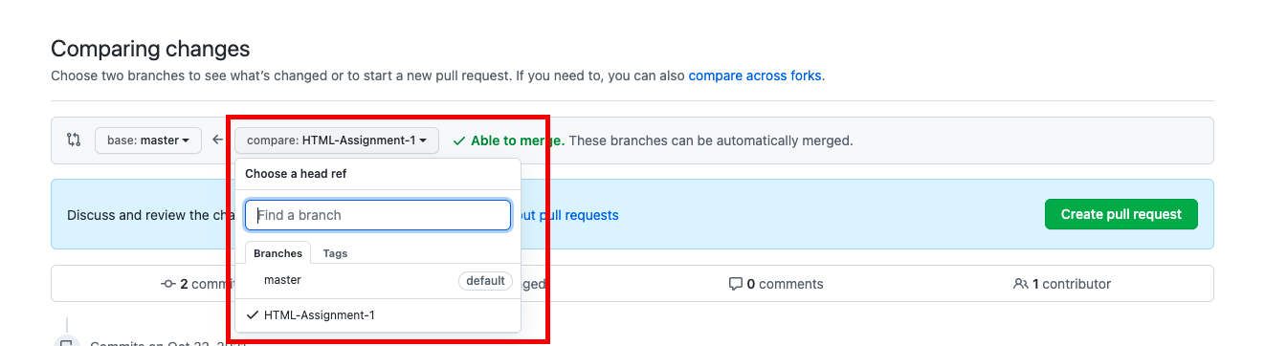
  - Create a pull request and share link of Request as your submission.
Please take screenshot of final output from your browser and keep in Pull Request description.
Share the Branch URL: https://github.com/{Username}/{Repo Name}/ pull/{Request Number}
